**Venture Capital**

**Study about data science Community Analytics Vidhya**



* Name :- Analytics Vidhya
* Tagline :- Learn Everything About Analytics
* Vision :- Wikipedia of Data Science
* Type :- Online Community for Data Science
* Location :- India
* Operation :- Global
* Launched on :- April 2013
* CEO :- Mr. Kunal Jain (IIT B Alumni)
* Website :- [www.analyticsvidhya.com](http://www.analyticsvidhya.com)
* Employees :- 1-10 Nos
* Activities :- Blogs,Trainings,Workshops,Meetups, Hackathons ,Jobs Portal,Discussion,Mentorship etc
* Followers* :- Linkedin : 1106 nos

Facebook : 13592 nos

Twitter : 4699 nos

Google+ : 1016 nos

**\*as on 24th Apr 2016**

**Analysis of Year 2015**



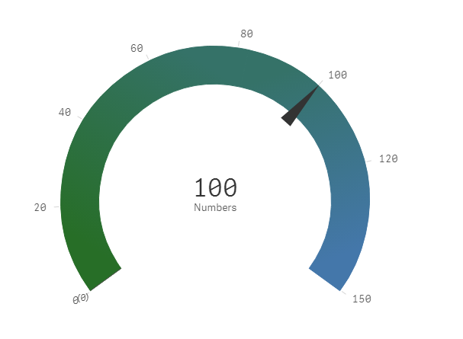

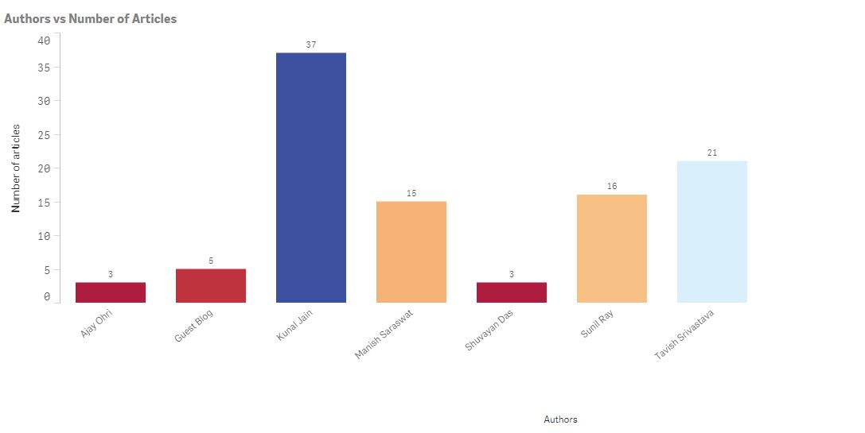

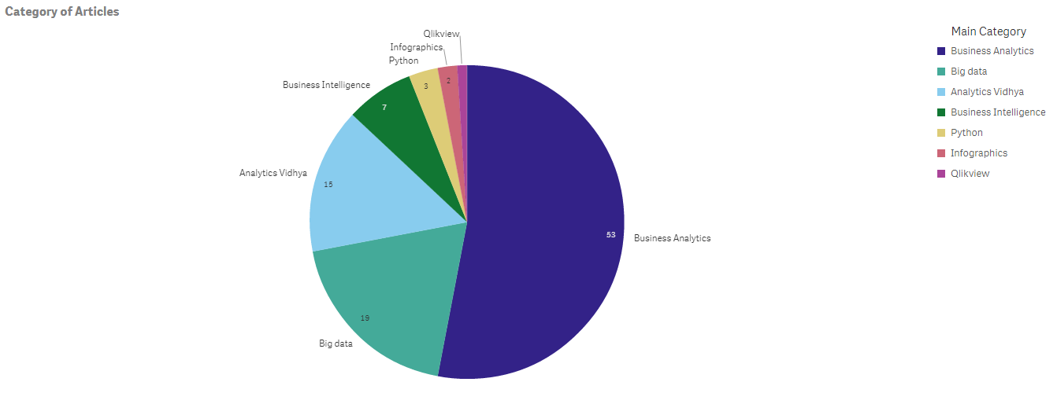

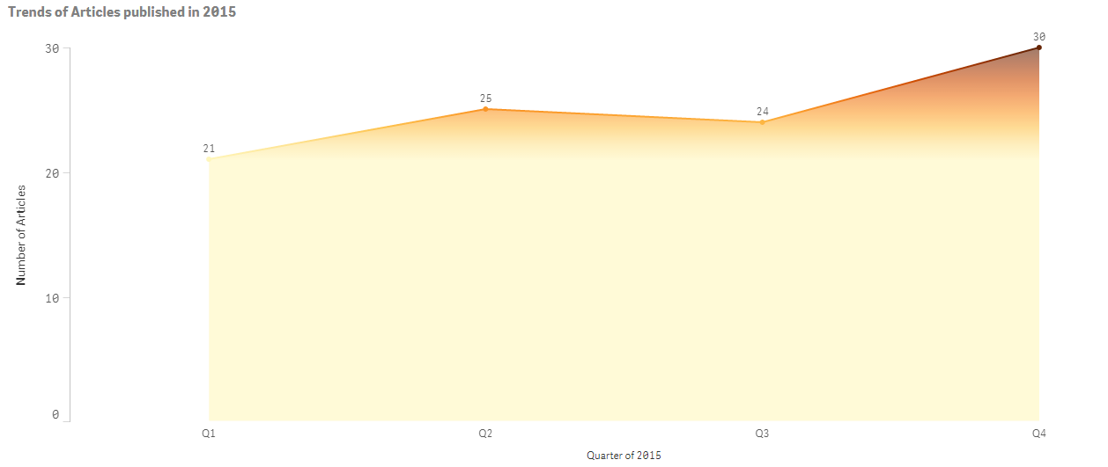

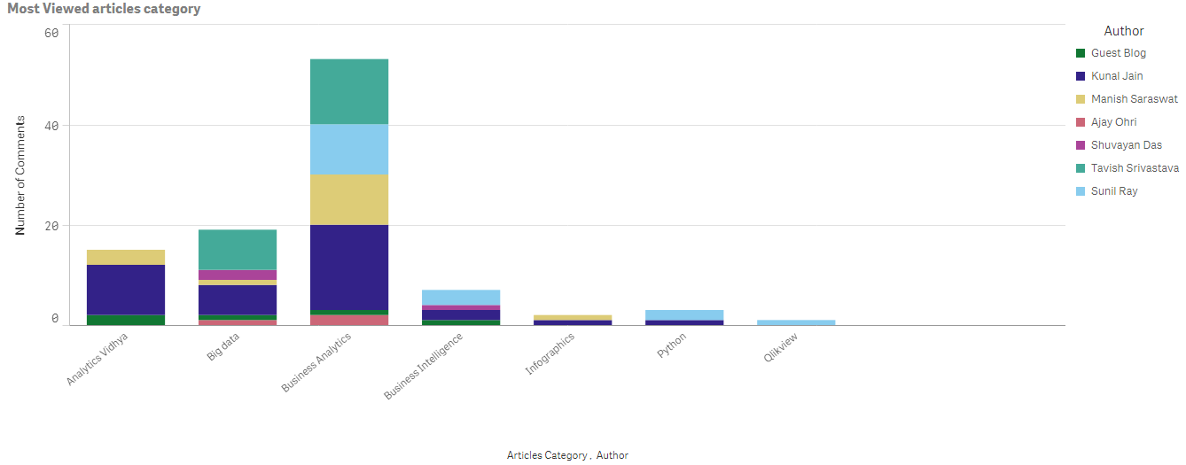

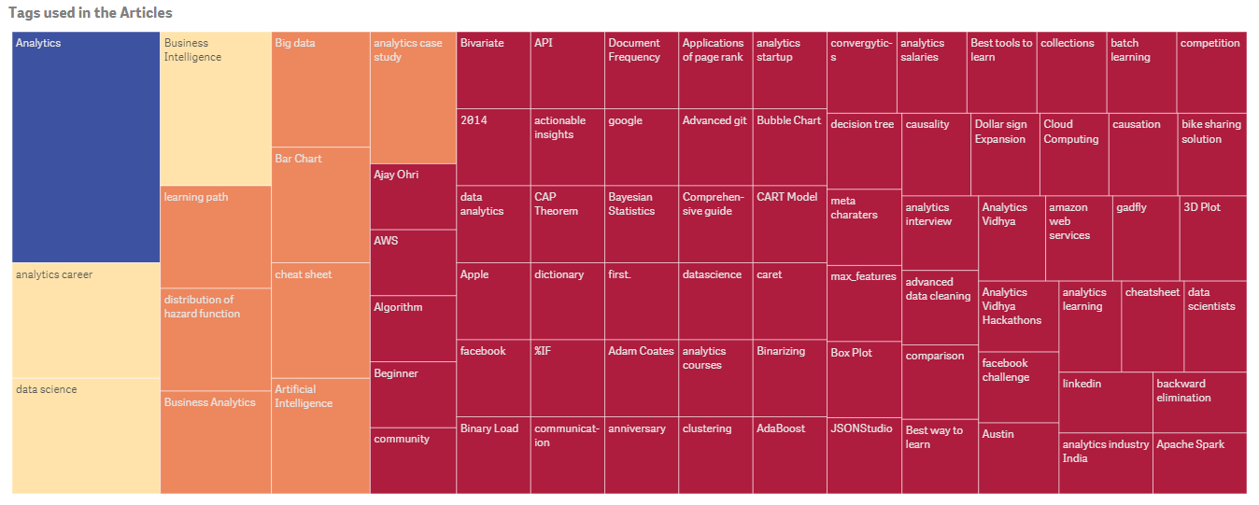

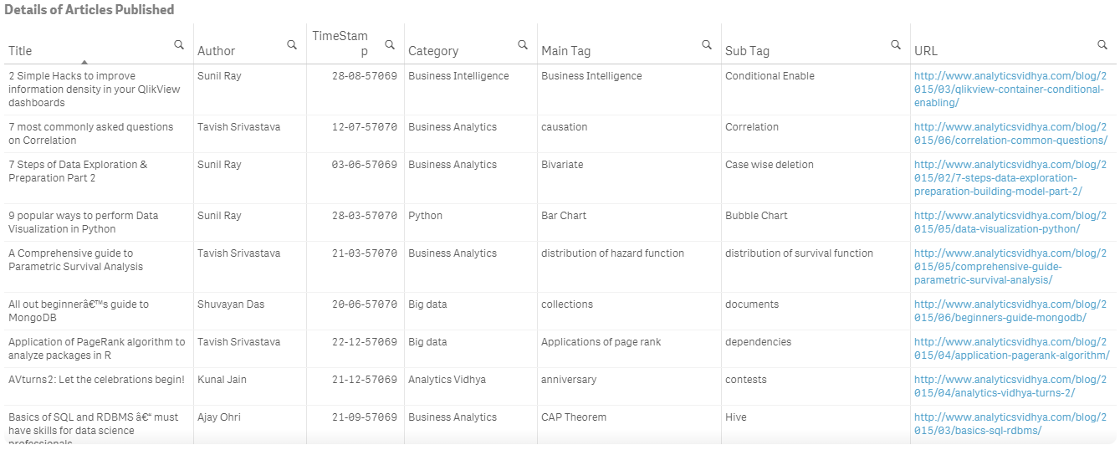**Refer the Qlikview Dashboard attached for a holistic view.**

**Funding Requirement**

**10 Million US Dollars**

**Why need Investment**

* Expansion of the community with more full time employees.
* Improving infrastructure like database expansion, live chat support etc for better quality and customer experience.
* Improving the marketing channels through Social Media, Ads and Campaign.
* For providing analytics training materials in the form of books and online courses.
* Increasing the prize amount for Hackathon competitions.
* For conducting more meetups and workshops.

**Thank You**